

Ninong & Ninang

Juley Tuba
Mario L. Cusong Jr.
Areto Engyo Jr.
Reynaldo Espina Jr.

Mary Grace Calang
Ursula Nica Tagerero
Mabeth Engyo
Angeline R. Manguiran

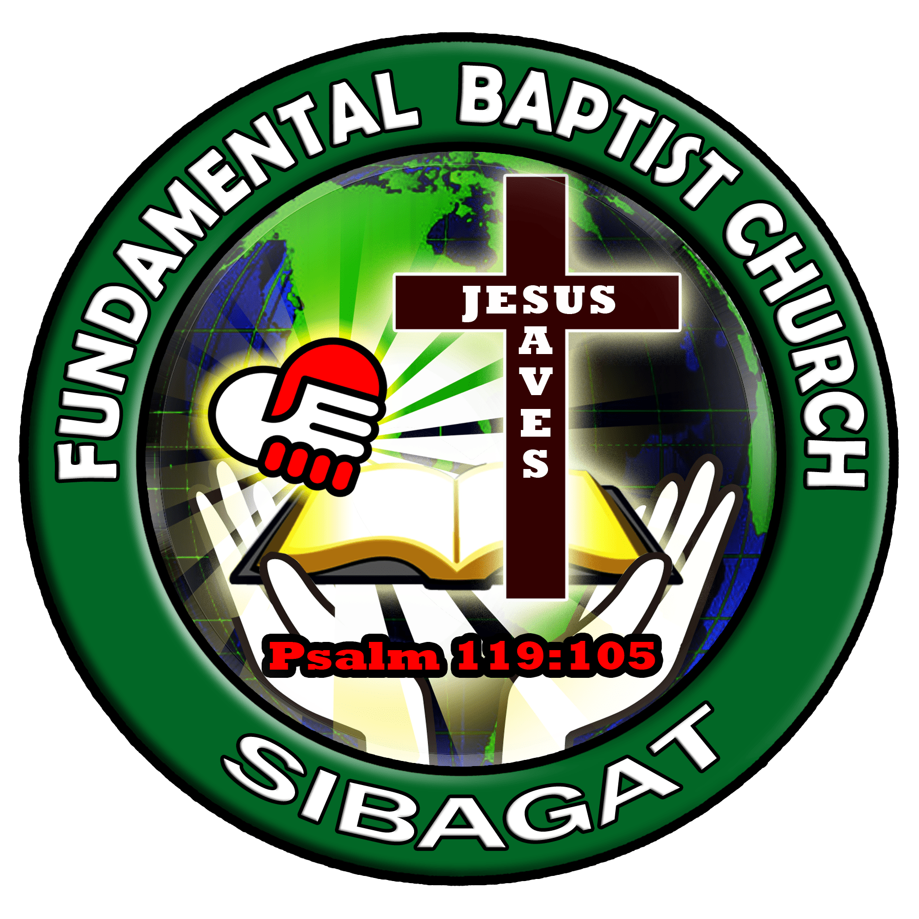
"Children are a heritage from the Lord, offspring a reward from him.".
Psalm 127:3

